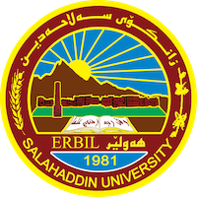

**Academic Curriculum Vitae**

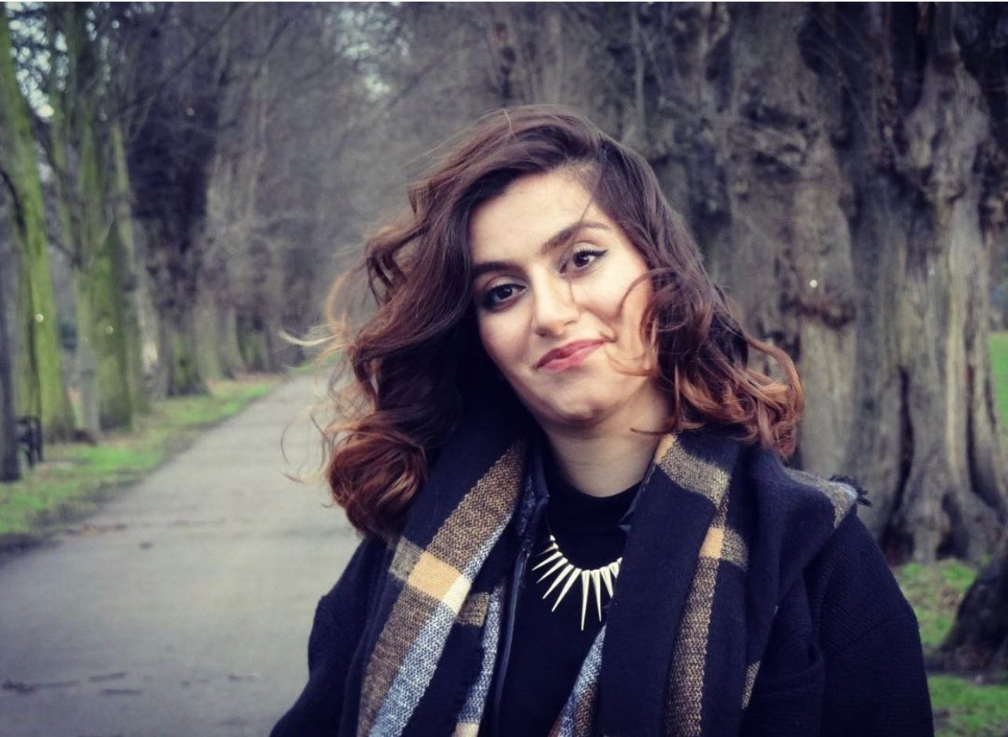

**Personal Information:**

Full Name: Awat Latif Qader

Academic Title: Assistant Lecturer

Email: awat.qader@su.edu.krd

Mobile: 009647504638496

**Education:**

**Undergraduate**

BSc in Architectural Engineering (2003-2008), Department of Architecture, College of Engineering, Salahaddin University-Erbil

**Post-graduate Studies**

MArch in Theory and Design (2014-2015), Department of Architecture and Built Environment,

Nottingham University- United Kingdom

**Employment:**

**Academic:**

-Research Assistant at Department of Architecture, College of Engineering, Salahaddin University-Erbil (2009-2020)

-Assistant Lecturer at Department of Architecture, College of Engineering, Salahaddin University-Erbil (2021- present)

**Non-Academic:**

**-**Founding Partner at Sketch Team- Architecture and Engineering Consultancy Bureau (License No. 7948), Erbil (2010-2014)

**Qualifications:**

**Teaching Qualification**:

- Teaching Methods Qualification (Pedagogy), Salahaddin University-Erbil (2017)

**Language Qualification:**

- Pre-sessional language Qualification, CELE, Nottingham University- UK (2013)

- Language Capacity Course, Language Centre, Salahaddin University-Erbil (2017)

- ELTS 6.5 Band (2021)

**Teaching experience:**

**Teaching Courses as an Assistant Engineer:**

* Architectural Design studio - 1st year (2017-2020)
* Architectural Design studio - 2nd year (2009-2013)
* Building Materials- 2nd year (2019-2020)
* Interior Design- 4th year (2010-2013)
* Landscape Design- 4th year (2010-2013)
* Working Drawing- 3rd year (2011-2012)
* Urban Design- 4th year (2012-2013)

**Teaching Courses as an Assistant Lecturer:**

* Architectural Design Studio 5- 3rd year (2021- present)
* Architectural Design Studio 6- 3rd year (2021- present)
* Academic Debate and Critical Thinking- 1st year (2021- present)
* Landscape Design- 4th Year (2021- present)

**Research and publications:**

* State all researches, publication you made.

**Conferences and courses attendance:**

* 2nd Grant conference for the best students’ project and idea, Salahaddin University- Erbil (2021-2022)
* 3rd Grant conference for the best students’ project and idea, Salahaddin University- Erbil (2022-2023)
* 4th Scientific conference for the best students’ graduation project and academic poster, Salahddin University- Erbil (2022)
* The 6th Annual Conference for best Academic poster and Graduation Project (2023-2024)
* AGIR-HIFAZ training course – An interdisciplinary course in the field of heritage conservation, (2022-2023)

**Funding and academic awards:**

* HCDP (Human Capacity Development Program) Scholarship Grant, From Ministry of Higher Education and Scientific Research – Kurdistan Region of Iraq (2014).

**Professional memberships**

* Kurdistan Engineers Union No. 6816 (Since 2008)

**Professional Social Network Accounts:**

* LinkedIn: https://www.linkedin.com/in/awat-latif-qader-b0141a279/
* Research Gate: https://www.researchgate.net/profile/Awat-Latif-Qader
* ORCID: https://orcid.org/0009-0002-7592-6636
* Google Scholar: https://scholar.google.com/citations?hl=en&view_op=list_works&gmla=AHoSzlW274dlxwcHpxF0oXrUQbZlwUs_NWoFGrjdTuyhtMooMia5cwgAH3M9NhBC71kNk8UgMvrJTa_sgVuHHg&user=nhO0uFMAAAAJ