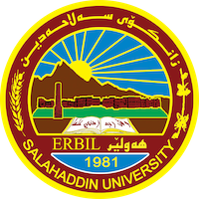
Academic Curriculum Vitae

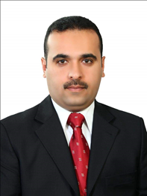
Personal Information:
Full Name: Mustafa Mohammed Mohammed
Academic Title: Assistant Lecturer
Email: mustafa.mohammed@su.edu.krd
Mobile: 07504721197

Education:
- BA. Of Engineering, University of Rafedain / Baghdad. Department of computer & communication engineering. 2008
- Msc. Of communications Eng. & networks, University of Birmingham / UK 2014

Employment:
- Accountant, Health director 2003.
- Hadi Co. as an IT supporter 2008.
- Baghdad Co. fibre optic maintenance 2008.
- Caterpillar (CAT) Co. Procurement engineer and IT Engineer 2009-2010.
- Radar Engineer in Radar unit / Erbil International Airport 2015 - 2022
- Assistant lecturer in international university of Erbil 2018-2019.
- Assistant lecturer in Nobel institution 2018-2020.
- Assistant lecturer in salahaddin university -Erbil 2022.
- Project Management Trainer in Top target company

Qualifications
- Training course in 2008 in the field of communications systems.
- USAID Organisation for training, 2010 in Managing and maintaining windows server.
- USAID Organisation for training, 2010 in computer networking management.
- Radar & RF sensor, 2013 in the University of Birmingham.
- Flying training courses in 2013-2014 in Coventry Airport/UK. Fly with Cessna 150- 152 and Grop 114 – 115.
- Mobil communication system, Sala haddin University & Korek Telecom 2014.
- International Trainer in field of e-Government, 2016 (South Korea)
- Radar maintenance and management course 2017 (United States of America).
- Strategic thinking course in 2018 KIPA center.
- Leader ship training course 2020/ USAID
- Planning and budgeting training course 2020 / USAID.
- Proposal writing –KIPA – Erbil / 2021

Teaching experience:
- Mathematic I CIS institute 2014 / undergraduate.
- Computer science Kurdistan institute 2015 / undergraduate
- Mobile communication Kurdistan institute 2016 / undergraduate
- Digital communication Nobel institute 2017-2018 / undergraduate
- Digital signal processing / Nobel institute 2018 / undergraduate
- Microwave and radar system / Erbil international university 2019 / undergraduate
- Microwave and radar / system Erbil international university 2020 / undergraduate
- Engineering mathematics / Salahaddin university 2022/ undergraduate
- Fundamental of Airport radar system / Salahaddin university 2023/ undergraduate
- e-government ministry of planning / as a trainer / 2017 – 2023
- project management / top target company / as a trainer / 2020 – 2023

Research and publications
- Author of the book e-administration / 2017.

Conferences and courses attended
- Ultra Wide-band Synthetic Aperture Radar, poster in Birmingham University /UK 2013
- Bistatic Radar Ambiguity Function, poster in Birmingham University /UK 2014

